Do you feel a special 'pull' to this Holy Island of Lindisfarne? Perhaps you have stayed here at Marygate House recently and enjoyed the time so much, you would love others to have the same opportunity? Or maybe you were a volunteer here some years ago?
The Companions of Marygate House is a new venture for us. The 'Thank you' cards we receive at the end of a stay are a continual reminder of the importance of the work of this House, particularly for those people who come here exhausted or burnt-out, or looking for a change of direction their life or a little cossetting before beginning a new stage in their life-journey.
"Thank you for providing us with such a lovely place for our retreat... Ideal for reflection, prayer and renewal"
"Thank you for deep peace and calm in this place..."
"Thank you for taking such good care of us this week, and for all you are doing to keep Marygate House running as such a lovely place of retreat."
We are looking for help from people like you, who recognise the uniqueness Marygate House and the work we do here. It may be that you are no longer so active and can't now visit here, but would like to support financially and through your prayers. You may ask your local church to support us a 'group' Companion. I hope you might be ambassadors for us, telling people about this place and the special retreats we run here. You may be someone excited by the idea of free bed and board here, and would like to get stuck into the side of Marygate House few people see during our Working Weeks!
The Companions of Marygate House is open to all who wish to support the work here.
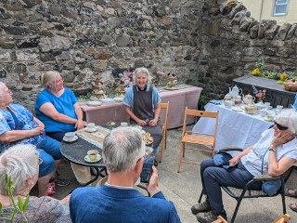
At present, Companions support the House financially (£25, 10, 5 or 'other' donation per month; or an annual donation), have an opportunity to pray with us on the first Monday of the month (on Zoom) and are invited to an Annual day in the Summer. A free bed and board 'working week' will take place each year where there will be plenty of fellowship, prayer and food, as well a jobs which don't get done when we are 'fully' open!
Our bank details are:
The Co-operative Bank
Marygate House Holy Island R/C
Sort code: 08 92 99
Account Number 65592977
The Co-operative Bank's SWIFT code is: CPBKGB22
IBAN: GB91 CPBK 0892 9965 5929 77
BIC: CPBK GB22
Please mark your donation, 'Companions'

